Week by Week CMALT plan
This timeline is for 16 weeks (approx.) gap between the assessment windows which are:
- 31 January for assessment during February, March and April and assessment result in May
- 31 May for assessment during June, July and August and assessment result in September
- 30 September for assessment during October, November and December and assessment result in January.
16 | 15 | 14 | 13 | 12 | 11 | 10 | 9
Plan | Draft (then review)

8 | 7 | 6 | 5 | 4 | 3 | 2 | 1
Evidence and reflection |  |  |  |  | Review Whole | Proof | Submit

Week 16
Read the CMALT Guidelines for Candidates - this is your ultimate guide for CMALT, and provides comprehensive guidance on how to approach the certification process, get started on building a portfolio and complete it successfully;
For each section you must provide:
- A description of what you have done;
- Evidence to support this;
- Reflection on what you learnt as a result of doing it.
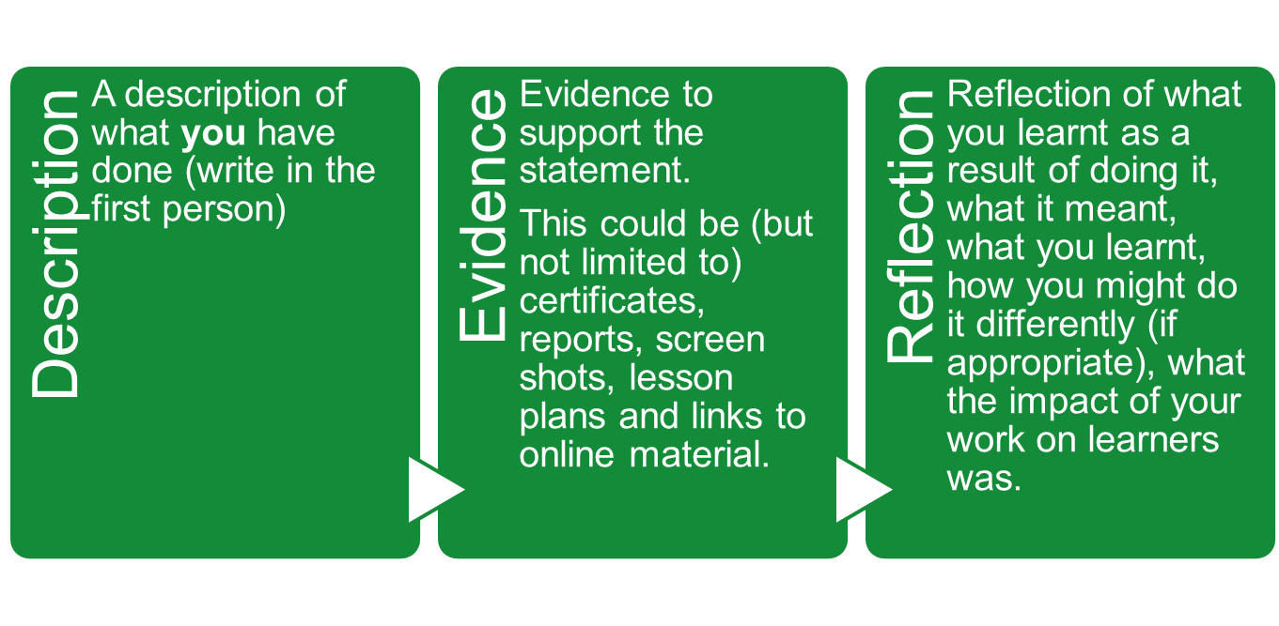
Draft your Contextual statement – this is not assessed but it vital to your assessors understanding who you are and the context of your work. Your application for the CMALT scheme, should be a good starting point for this. You can include links to a CV or public profiles such as LinkedIn.

Week 15
Some CMALT holders share their portfolios openly with ALT members. You will need to be logged in to the ALT site as a member to view the list of shared portfolios.
Decided how you are going to present your portfolio? You can use any format you want to, examples include: Word, PDF, PebblePad, WordPress, Google Sites. It doesn’t have to be just text (but equally it can be!) - You can include audio, video, multimedia and links (make sure they are open or provide a password).
Are you going to write directly into this format, or draft it elsewhere – perhaps in Word? Look at the shared portfolios for ideas and decide what works best for you. Set up the format with all of the headings in place to give you the shape of the portfolio and make sure you don’t forget any sections.
Contextual Statement
Future Plans
Confirmation
Core area 1: Operational issues
- An understanding of the constraints and benefits of different technologies
- Technical knowledge and ability in the use of learning technology
- Supporting the deployment of learning technologies
Core area 2: Teaching, learning and/or assessment processes
- An understanding of Teaching, learning and/or assessment processes
- An understanding of your target learners
Core area 3: The Wider Context
- Legislation (include the name)
- Legislation or Policy (include the name)
Core area 4: Communicating and working with others
Core area: Specialist Option(s)

Draft: Future Plans

Week 14
Drafting - You will probably be mainly writing descriptively at this stage, but don’t worry, reflection will come when you review this. Get something on paper - notes are a good starting point. Use the meetings to talk to others about their experiences and what they would include.
Don’t feel your work as too be too perfect at this stage – I recommend reading this short article for inspiration Anne Lamott from Bird by Bird, Shitty First Drafts:
https://wrd.as.uky.edu/sites/default/files/1-Shitty%20First%20Drafts.pdf
Draft: Core area 1: Operational issues
- An understanding of the constraints and benefits of different technologies
- Technical knowledge and ability in the use of learning technology
- Supporting the deployment of learning technologies

Week 13
Draft: Core area 2: Teaching, learning and/or assessment processes
- An understanding of Teaching, learning and/or assessment processes
- An understanding of your target learners

Review - Core area 1: Operational issues
When you review – Write in sentences, think about your notes as a narrative, start to tell a story. Start to reflect on what you wrote the week before (see review questions under week 8).

Week 12
Draft: Core area 3: The Wider Context
- Legislation (include the name)
- Legislation or Policy (include the name)
Review- Core area 2: Teaching, learning and/or assessment processes

Week 11
Draft: Core area 4: Communicating and working with others
Review- Core area 3: The Wider Context

Week 10
Draft: Core area: Specialist Option(s)
Review - Core area 4: Communicating and working with others

Have you written notes or a draft for each section?

Make sure the description include the detail required for someone outside your workplace to understand the context – expand acronyms, and explain what they mean e.g. “ I work in the Information Services Group which provides central University support for all IT and library services. “ Include dates, so your assessors understand the time frames.

Do you have a plan set out for when you are going to draft or redraft the next sections?

Week 9
Have you drafted something for each area?
Have you reviewed your draft and written it into a narrative?
Have you included links to evidence?
Do you have all the evidence you need?
Do you need to approach anyone, for additional evidence, such as a reference?

Remember to explain why you have selected the evidence, you might want to include a sentence about each item. I have includes X as evidence of Y because it shows….

Week 8
Remember your reflection is key – your assessor wants to know not just what you have done but what you have learned from it.

You should now have some distance from the draft you wrote, think about why you selected the examples you have. What in particular have you learned from these?

Look at these reflection questions for every section:

What have I learnt from doing what I described above?
What went well/ what could have gone better?
What would I do differently another time?
What was the impact on my users/students/learning?

Week 7
Look at your portfolio as a whole, review your contextual statement and future plans. Is there anything further you want to add?

Think about your last year at work:
What were your high points?
What have you learned this year?
What do you want to learn next year?
Are all areas of your portfolio as well written and thought out? Can you identify any you want to work on further?

Week 6
Can someone review your portfolio draft for you? Speak to Susan Greig or other CMALT holders or applicants.

Review your complete draft

Week 5
Remember that your portfolio is also assessed against the
ALT Principles and values
“Learning technology is the broad range of communication, information and related technologies that can be used to support learning, teaching, and assessment.”
The principles and values that inform the development of the scheme are:
- A commitment to exploring and understanding the interplay between technology and learning.
- A commitment to keep up to date with new technologies.
- An empathy with and willingness to learn from colleagues from different backgrounds and specialist options.
- A commitment to communicate and disseminate effective practice.

Review your draft with this in mind

Week 4
Take another look at the portfolio sharing imitative – does it give you any ideas? Have you missed anything? You will need to be logged in to the ALT site as a member to view the list of shared portfolios
Peer review session – bring drafts ready to share with each other and we can review these against the CMALT Assessment Form which can be found on https://www.alt.ac.uk/certified-membership/cmalt-support

Week 3
Review your entire portfolio and proof read it.

Week 2
Proof read – can you ask a friend or relation to read the whole portfolio for grammar, spelling and sense.

Week 1
The submission guidelines can be found here: https://www.alt.ac.uk/certified-membership/submitting-portfolio
Submit your portfolio by using this submission form. You will receive a confirmation by email.

